ENG 463-L1

Lab #2 ARM Pipeline Implementation

Brian Worts and Chris Jenson

03/16/21



**Table of Contents**

Introduction………………………………………………………………………………………. 2

Problem Statement…...…………………………………………………………………………... 2

Procedure/Results…...……...…...……………………………………………………………….. 4

Discussion………………………………………………………………………………………..10

Conclusion ................................................................................................................................... 10

Appendix A (Arm Assembly)....................................................................................................... 11

Appendix B (Initial Memory)....................................................................................................... 11

Appendix C (Verilog Files)........................................................................................................... 12

**Introduction:**

For this lab, a pipelined ARM architecture processor will be implemented and verified in Verilog. Pipelining is the process of fetching the next instruction while the current instruction is being executed. This is supported by the processor to increase the speed of program execution. ARM processors are based on the RISC (reduced instruction set computer) architecture to perform a smaller set of instructions at high speeds. They provide high performance while requiring considerably less power than devices using CISC (complex instruction set computing). By having less instructions, they require fewer transistors allowing for small sizes of the integrated circuitry. The ARM processor’s smaller size, low complexity, and lower power usage make them ideal for small devices.

**Problem Statement:**

Implement the pipelined ARM architecture using an as high as possible level of abstract design methodology. The implementation will only have to support the following instructions (simplified ISA): LDUR, STUR, ADD, SUB, AND, ORR, and CBZ. The architecture will be designed based on *Figure 1*. The memories, as well as the register file, are of the asynchronous read, synchronous write type. The control is based on *Figures 2 & 3*. The design must be verified using a testbench.

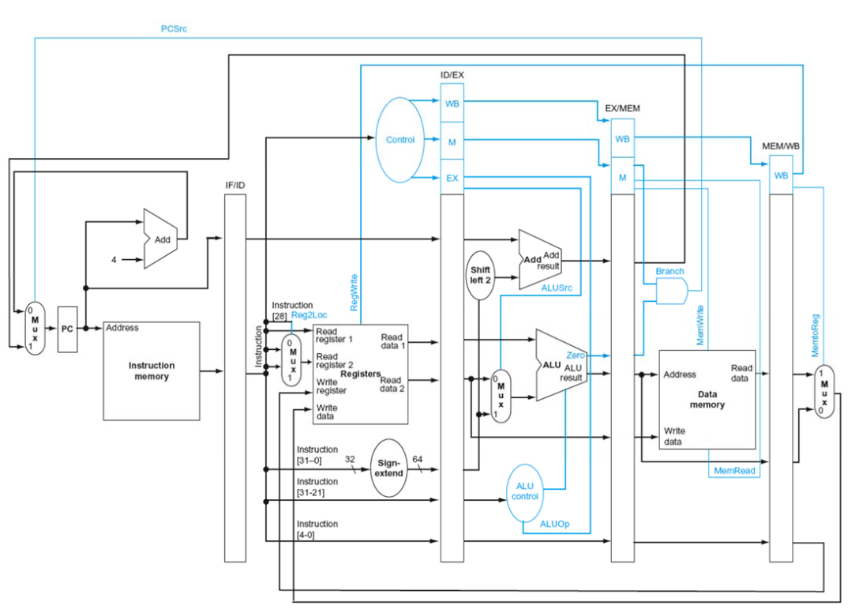

Figure 1: Overall Architecture

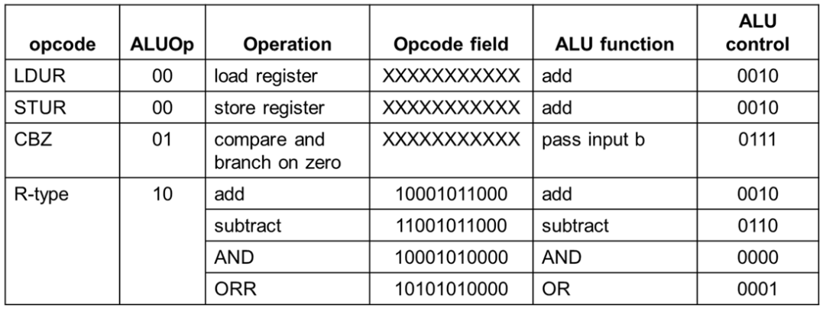

Figure 2: ALU Control Truth Table

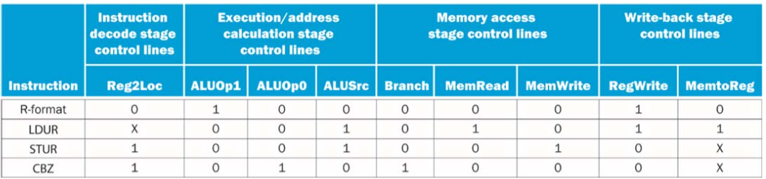

Figure 3: Main Control Truth Table

**Procedure/Results:**

The group started by looking at Lab 5 from ELC 363 where a simplified version of the processor was made. The IM, DM, and register blocks were still applicable to this design. The IM, DM, and RM (register map) files followed the same principle but IM had to be changed to avoid data hazards. The instructions were chosen to create a comprehensive test of the system and were originally written in Arm Assembly Language:

Add X1, X2, X3

And X4, X5, X6

Sub X7, X8, X9

Orr X10, X11, X12

Ldur X14, [X13, #0]

Stur X16, [X15, #0]

Add X17, X18, X19

Cbz X0, #-16

The instructions were then broken down into their components based on format in binary and then converted into hexadecimal. This is shown in **Table 1**.

**Table 1*:*** This table shows the deconstruction of the instructions

|  |  |  |  |  |  |  |  |  |  |  |
| --- | --- | --- | --- | --- | --- | --- | --- | --- | --- | --- |
| Assembly | Instruct | Opcode | Rm | Shamt | Add | Op | Rn | Rd/Rt | Hex | Binary |
| Add X1, X2, X3 | ADD | 10001011000 | 00010 | 000000 |  |  | 00011 | 00001 | 8B020061 | 10001011000000100000000001100001 |
| And X4, X5, X6 | AND | 10001010000 | 00101 | 000000 |  |  | 00110 | 00100 | 8A0500C4 | 10001010000001010000000011000100 |
| Sub X7, X8, X9 | SUB | 11001011000 | 01000 | 000000 |  |  | 01001 | 00111 | CB080127 | 11001011000010000000000100100111 |
| Orr X10, X11, X12 | Or | 10101010000 | 01011 | 000000 |  |  | 01100 | 01010 | AA0B018A | 10101010000010110000000110001010 |
| Ldur X14, [X13, #0] | LDUR | 11111000010 |  |  | 000000000 | 00 | 01101 | 01110 | F84001AE | 11111000010000000000000110101110 |
| Stur X16, [X15, #0] | STUR | 11111000000 |  |  | 000000000 | 00 | 10000 | 01111 | F800020F | 11111000000000000000001000001111 |
| Add X17, X18, X19 | ADD | 10001011000 | 10010 | 000000 |  |  | 10011 | 10001 | 8B120271 | 10001011000100100000001001110001 |
| Cbz X0, #-16 | CBX | 10110100 |  |  | 1111111111111111000 |  |  | 00000 | B4FFFF80 | 1011010011111111 1111111100010000 |

With the inputs, outputs, and instructions prepared, the group moved on to construct the various basic modules the design would need. These modules include the MUX’s, add blocks, shift block, and the sign extend. The pipes between modules were ready to be connected. Starting with the ALU. Here is where the operations are performed based on the opcode and the registers defined in the instruction.

A major block to be programmed was the control block. This block determined the control lines based on the instruction. Control lines go to the various MUX’s and influence what the processor is executing by determining what is passed on to the blocks. With all of these components finished, simulation was used to check if it was performing as desired. The results are shown below in Figures 4-9.

The simulation was run with a 100MHz clock signal and a 1ns propagation delay for all assignments. In Figures 4-9, the blue dividers represent the different sections of the pipelined processor: IF, ID, EX, MEM, and WB as labeled in the figures. The figures show red boxes around each clock cycle to show the progression of commands through the processor. The commands are written in the pink boxes inside of the pipeline dividers. Lastly, the values stored in each register and each memory location are equal to the index of each register. For example, X4 holds value 4 unless changed via an instruction.

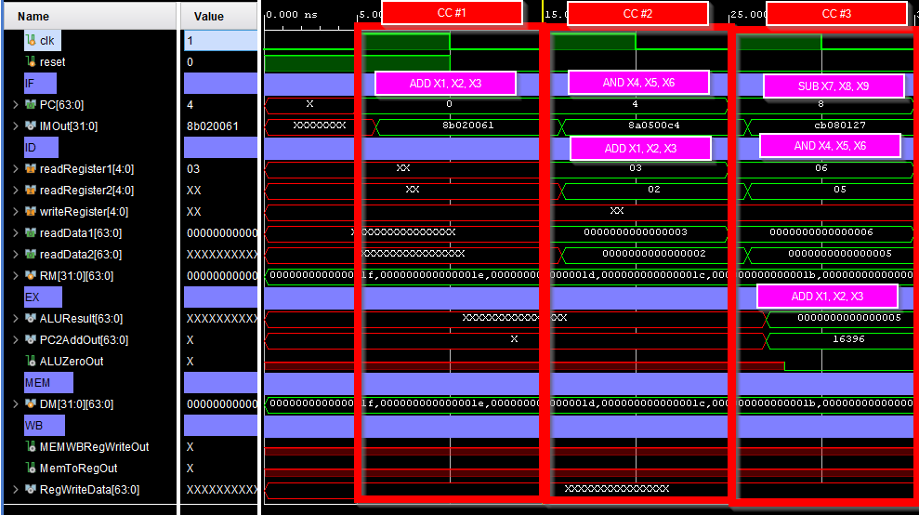

Figure 4: First 3 clock cycles of pipeline, showing instructions moving through the pipeline and modules working as expected

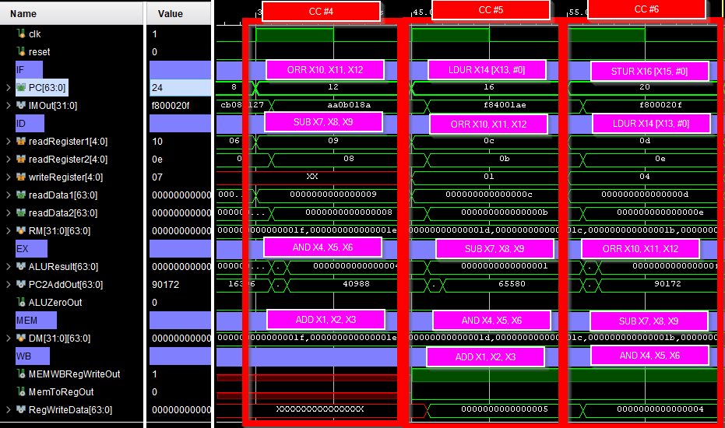

Figure 5: Clock cycles 4-6 of pipeline, showing instructions moving through the pipeline and modules working as expected. ADD and AND successfully complete in this figure. Figure 8 shows the registers changing appropriately.

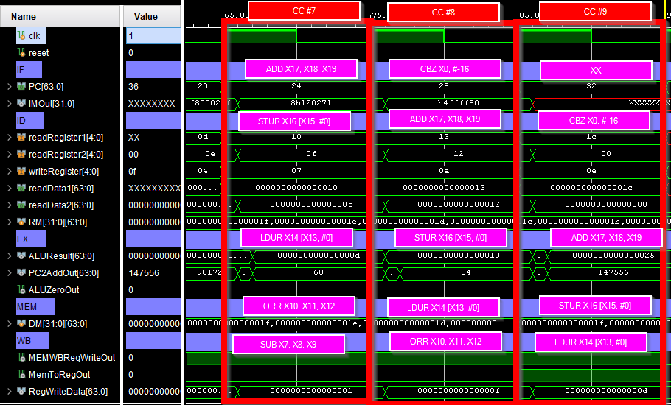

Figure 6: Clock cycles 7-9 of pipeline, showing instructions moving through the pipeline and modules working as expected. SUB, ORR, and LDUR successfully complete in this figure. Figure 8 shows the registers changing appropriately.

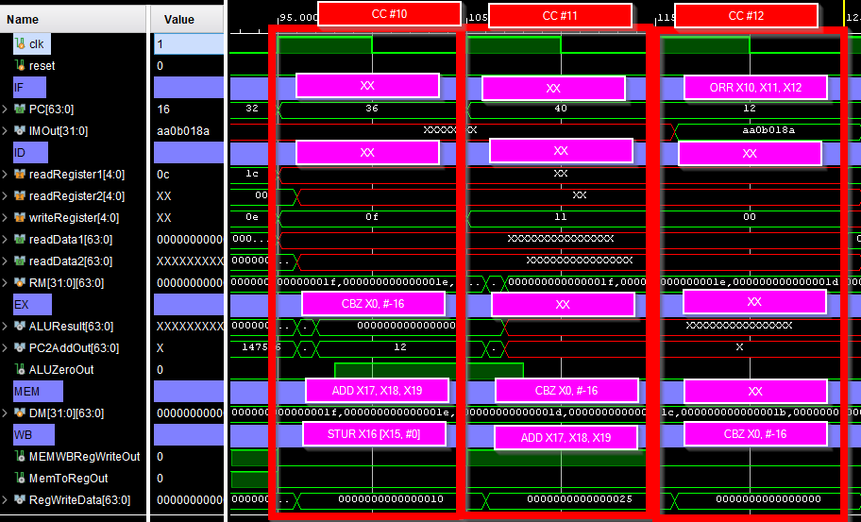

Figure 7: Clock cycles 10-12 of pipeline, showing instructions moving through the pipeline and modules working as expected. STUR, ADD, and CBZ successfully complete in this figure. Figure 8 shows the registers changing appropriately and Figure 9 shows the DM changing appropriately for STUR. PC can be seen in this image to be 16 less than it is in the MEM section of the pipeline (28 - 16 = 12) because of the CBZ instruction.

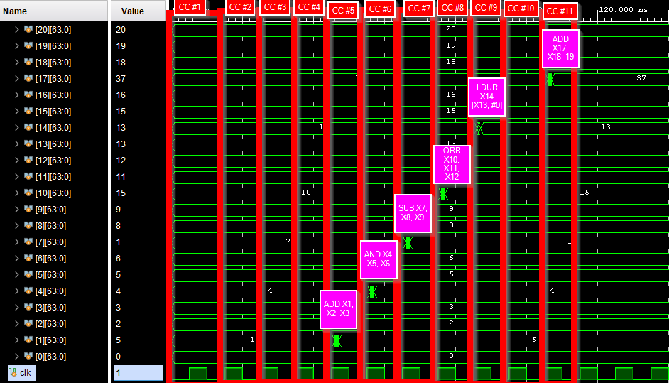Figure 8: Registers changing with pipeline clock cycle shown in red at the top and the instructions in the pink boxes. The pink boxes are located directly above the register they are changing.

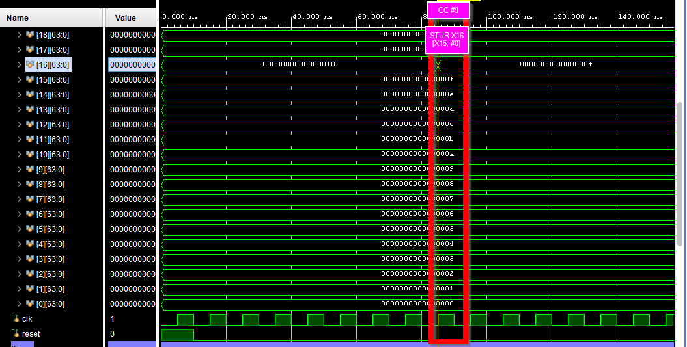

Figure 9: Data Memory with the STUR instruction highlighted in red, where it alters DM in the pipeline

**Discussion:**

One of the issues the group encountered was that there are an exorbitant amount of wires across the design. Naming conventions had to be strictly followed to avoid bugs and confusion throughout the entire process. A second issue the group had to account for was the possibility of data hazards. This wasn’t a potential issue in ELC 363 because the processor ran in a single clock cycle. Pipelined processors run over multiple cycles which is where data hazards occur. An instruction may intend to alter the value in a register which a later process accesses. In this case, the later process might not get the correct value because the first process did not finish executing.

**Conclusion:**

The use of a testbench with simulation showed that the design in *Figure 1* was successfully implemented. Memory was able to be read in and written to. The waveforms in the Results section showed that the state of the CPU (PC and pertinent registers), and the pertinent memory contents after each instruction was executed matched what was expected. Implementing this design gave the group a deeper understanding of the ARM architecture as how it may be implemented in a real world application. It also showed the value of ARM implementations over potential other architectures due to its simplified nature.

**Appendix A (ARM Assemble Test Program):**

Add X1, X2, X3

And X4, X5, X6

Sub X7, X8, X9

Orr X10, X11, X12

Ldur X14, [X13, #0]

Stur X16, [X15, #0]

Add X17, X18, X19

Cbz X0, #-16

**Appendix B (Initial Program Memory Load File):**

@0 8B020061

@4 8A0500C4

@8 CB080127

@c AA0B018A

@10 F84001AE

@14 F800020F

@18 8B120271

@1c B4FFFF80

**Appendix C (Verilog Files):**

`timescale 1ns / 1ps

module testbench();

//////////////////////////////////////////

//CLK

reg clk;

//Generate Clock

initial

begin

clk = 0;

while(1)

begin

#5 clk = ~clk;

end

end

/////////////////////////////////////////////

//Reset

reg reset; //Active Low

initial

//Initize reset

begin

reset = 1;

#10 reset = 0;

end

////////////////////////////////////////////

always @(posedge clk)

//FRAME

begin

if (reset)

begin

end

else

begin

end

end

wire [63:0] PC;

//////////////////////////////////////////////

//IM

wire [31:0] IMOut;

IM u_IM (

.PC(PC),

.IMOut(IMOut)

);

//////////////////////////////////////////////

//DM

wire DMMemWrite;

wire DMMemRead;

wire [63:0] DMAddress;

wire [63:0] DMWriteData;

wire [63:0] DMReadData;

DM u_DM(

.DMMemWrite(DMMemWrite),

.DMMemRead(DMMemRead),

.DMAddress(DMAddress),

.DMWriteData(DMWriteData),

.DMReadData(DMReadData)

);

//////////////////////////////////////////////

Datapath u_Datapath (

.clk(clk),

.reset(reset),

//PC

.PC(PC),

//IM

.IFIMOut(IMOut),

//DM

.DMMemWrite(DMMemWrite),

.DMMemRead(DMMemRead),

.DMAddress(DMAddress),

.DMWriteData(DMWriteData),

.DMReadData(DMReadData)

);

endmodule

`timescale 1ns / 1ps

module IM(

input [63:0] PC,

output [31:0] IMOut

);

reg [31:0] IM[31:0];

initial

begin

//Initialize IM

$readmemh("D:/CELab2/ARM-Pipeline-Processor/IM.dat", IM);

end

assign #1 IMOut = IM[PC];

Endmodule

`timescale 1ns / 1ps

module DM(

input DMMemWrite,

input DMMemRead,

input [63:0] DMAddress,

input [63:0] DMWriteData,

output [63:0] DMReadData

);

reg [63:0] DM[31:0];

initial begin

//Initialize IM

$readmemh("D:/CELab2/ARM-Pipeline-Processor/DM.dat", DM);

end

assign DMReadData = DM[DMAddress];

always @(*)

begin

if (DMMemWrite)

begin

DM[DMAddress] = DMWriteData;

end

end

endmodule

`timescale 1ns / 1ps

//Async read, sync write

//if write and read at same time, should read old value

module Datapath(

input clk,

input reset,

//PC

output [63:0] PC,

//IM

input [31:0] IFIMOut,

//DM

output DMMemWrite,

output DMMemRead,

output [63:0] DMAddress,

output [63:0] DMWriteData,

input [63:0] DMReadData

);

////////////////////////////////

//IF

wire PCSrc;

wire [63:0] PCMuxOut;

wire [63:0] PCAddOut;

wire [63:0] EXMEMPCAdd2Out;

Mux u_PCMux(

.inputA(PCAddOut),

.inputB(EXMEMPCAdd2Out),

.selector(PCSrc),

.outputData(PCMuxOut)

);

Add u_PCAdd(

.inputA(PC),

.inputB(64'd4), //Always add 4

.outputData(PCAddOut)

);

PC u_PC(

.clk(clk),

.reset(reset),

.PC(PC),

.PCMuxOut(PCMuxOut)

);

//////////////////////////////////

//IF/ID

wire [63:0] IFIDPCOut;

wire [31:0] IFIDIMOut;

IF_ID u_IF_ID(

.clk(clk),

.reset(reset),

.IFIDPCIn(PC),

.IFIDPCOut(IFIDPCOut),

.IFIDIMIn(IFIMOut),

.IFIDIMOut(IFIDIMOut)

);

//////////////////////////////////

//ID

wire [4:0] ReadRegister2In;

wire [4:0] Reg2MuxAIn;

wire [4:0] Reg2MuxBIn;

wire Reg2Loc;

assign Reg2Loc = IFIDIMOut[28];

assign Reg2MuxAIn = IFIDIMOut[20:16];

assign Reg2MuxBIn = IFIDIMOut[4:0];

Mux u_RegsMux(

.inputA(Reg2MuxAIn),

.inputB(Reg2MuxBIn),

.selector(Reg2Loc),

.outputData(ReadRegister2In)

);

wire [4:0] ReadRegister1In;

wire [4:0] WriteRegister;

wire [63:0] RegWriteData;

wire [63:0] ReadData1;

wire [63:0] ReadData2;

wire [63:0] InsSignExtendOut;

wire MEMWBRegWriteOut;

Registers u_Registers(

.readRegister1(IFIDIMOut[9:5]),

.readRegister2(ReadRegister2In),

.writeRegister(WriteRegister),

.writeData(RegWriteData),

.regWrite(MEMWBRegWriteOut),

.readData1(ReadData1),

.readData2(ReadData2)

);

assign #1 InsSignExtendOut = { {32{IFIDIMOut[31] }}, IFIDIMOut[31:0] };

wire [1:0] WBControlOut;

wire [2:0] MControlOut;

wire [2:0] EXControlOut;

Control u_Control(

.Instruction(IFIDIMOut),

.WB(WBControlOut),

.M(MControlOut),

.EX(EXControlOut)

);

//////////////////////////////////

//ID/EX

wire [1:0] IDEXWBControlOut;

wire [2:0] IDEXMOut;

wire [1:0] IDEXALUOpOut;

wire IDEXALUSrcOut;

wire [63:0] IDEXPCOut;

wire [63:0] IDEXReadData1Out;

wire [63:0] IDEXReadData2Out;

wire [63:0] IDEXSignExtendOutOut;

wire [10:0] IDEXOpcodeOut;

wire [4:0] IDEXWriteRegisterOut;

ID_EX u_ID_EX(

.clk(clk),

.IDEXWBIn(WBControlOut),

.IDEXWBOut(IDEXWBControlOut),

.IDEXMIn(MControlOut),

.IDEXMOut(IDEXMOut),

.IDEXEXIn(EXControlOut),

.IDEXALUOpOut(IDEXALUOpOut),

.IDEXALUSrcOut(IDEXALUSrcOut),

.IDEXPCIn(IFIDPCOut),

.IDEXPCOut(IDEXPCOut),

.IDEXReadData1In(ReadData1),

.IDEXReadData1Out(IDEXReadData1Out),

.IDEXReadData2In(ReadData2),

.IDEXReadData2Out(IDEXReadData2Out),

.IDEXSignExtendOutIn(InsSignExtendOut),

.IDEXSignExtendOutOut(IDEXSignExtendOutOut),

.IDEXOpcodeIn(IFIDIMOut[31:21]),

.IDEXOpcodeOut(IDEXOpcodeOut),

.IDEXWriteRegisterIn(IFIDIMOut[4:0]),

.IDEXWriteRegisterOut(IDEXWriteRegisterOut)

);

//////////////////////////////////

//EX

wire [63:0] PC2AddOut;

reg [20:0] IDEXSignExtendOutOutShifted;

always @(*)

begin

IDEXSignExtendOutOutShifted = #1 (IDEXSignExtendOutOut[23:5] << 2);

end

BranchAdd u_BranchAdd(

.inputA(IDEXPCOut),

.inputB(IDEXSignExtendOutOutShifted), //Shift Left 2

.outputData(PC2AddOut)

);

wire [63:0] ALUMuxOut;

Mux u_ALUMux(

.inputA(IDEXReadData2Out),

.inputB(IDEXSignExtendOutOut),//DEBUG BITS???????????????????????????

.selector(IDEXALUSrcOut),

.outputData(ALUMuxOut)

);

wire [63:0] ALUResult;

wire ALUZeroOut;

wire [3:0] ALUControlOut;

ALUControl u_ALUControl(

.OpcodeIn(IDEXOpcodeOut),

.ALUOp(IDEXALUOpOut),

.ALUControlOut(ALUControlOut)

);

ALU u_ALU(

//Input Data

.inputA(IDEXReadData1Out),

.inputB(ALUMuxOut),

//ALUOp

.ALUOp(IDEXALUOpOut),

//Control

.ALUControl(ALUControlOut),

//Output Data

.ALUOutput(ALUResult),

.Zero(ALUZeroOut)

);

//////////////////////////////////

//EX/MEM

wire [1:0] EXMEMWBOut;

wire EXMEMBranchOut;

wire EXMEMMemWriteOut;

wire EXMEMMemReadOut;

wire EXMEMALUZeroOut;

wire [63:0] EXMEMALUResultOut;

wire [63:0] EXMEMReadData2Out;

wire [4:0] EXMEMWriteRegisterOut;

EX_MEM u_EX_MEM(

.clk(clk),

.EXMEMWBIn(IDEXWBControlOut),

.EXMEMWBOut(EXMEMWBOut),

.EXMEMMIn(IDEXMOut),

.EXMEMBranchOut(EXMEMBranchOut),

.EXMEMMemWriteOut(EXMEMMemWriteOut),

.EXMEMMemReadOut(EXMEMMemReadOut),

.EXMEMPC2AddIn(PC2AddOut),

.EXMEMPC2AddOut(EXMEMPCAdd2Out),

.EXMEMALUZeroIn(ALUZeroOut),

.EXMEMALUZeroOut(EXMEMALUZeroOut),

.EXMEMALUResultIn(ALUResult),

.EXMEMALUResultOut(EXMEMALUResultOut),

.EXMEMReadData2In(IDEXReadData2Out),

.EXMEMReadData2Out(EXMEMReadData2Out),

.EXMEMWriteRegisterIn(IDEXWriteRegisterOut),

.EXMEMWriteRegisterOut(EXMEMWriteRegisterOut)

);

//////////////////////////////////

//MEM

assign PCSrc = EXMEMBranchOut & EXMEMALUZeroOut;

assign DMAddress = EXMEMALUResultOut;

assign DMWriteData = EXMEMReadData2Out;

assign DMMemWrite = EXMEMMemWriteOut;

assign DMMemRead = EXMEMMemReadOut;

//////////////////////////////////

//MEM/WB

wire MemToRegOut;

wire [63:0] MEMWBDMReadDataOut;

wire [63:0] MEMWBALUResultOut;

wire [4:0] MEMWBWriteRegisterOut;

MEM_WB u_MEM_WB(

.clk(clk),

.MEMWBWBIn(EXMEMWBOut),

.MEMWBRegWriteOut(MEMWBRegWriteOut),

.MEMWBMemToRegOut(MemToRegOut),

.MEMWBDMReadDataIn(DMReadData),

.MEMWBDMReadDataOut(MEMWBDMReadDataOut),

.MEMWBALUResultIn(EXMEMALUResultOut),

.MEMWBALUResultOut(MEMWBALUResultOut),

.MEMWBWriteRegisterIn(EXMEMWriteRegisterOut),

.MEMWBWriteRegisterOut(MEMWBWriteRegisterOut)

);

//////////////////////////////////

//WB

Mux u_WBMux(

.inputA(MEMWBALUResultOut),

.inputB(MEMWBDMReadDataOut),

.selector(MemToRegOut),

.outputData(RegWriteData)

);

assign WriteRegister = MEMWBWriteRegisterOut;

//////////////////////////////////

endmodule

`timescale 1ns / 1ps

module Mux(

input clk,

input reset,

input [63:0] inputA,

input [63:0] inputB,

input selector,

output reg [63:0] outputData

);

always @(*)

//Select data in Mux

//Output

//outputData

begin

if(reset)

begin

//#1 outputData = 0;

end

else

begin

if (selector)

begin

#1 outputData = inputB;

end

else

begin

#1 outputData = inputA;

end

end

end

/*

always @(posedge clk)

//Select data in Mux

//Output

//outputData

begin

if(reset)

begin

outputData <= 0;

end

else

begin

if (selector)

begin

outputData <= inputB;

end

else

begin

outputData <= inputA;

end

end

end*/

endmodule

`timescale 1ns / 1ps

module Add(

input clk,

input reset,

input [63:0] inputA,

input [63:0] inputB,

output reg [63:0] outputData

);

always @(*)

begin

if (reset)

begin

// #1 outputData = 0;

end

else

begin

#1 outputData = inputA + inputB;

end

end

/*

always @(posedge clk)

begin

if (reset)

begin

outputData <= 0;

end

else

begin

outputData <= inputA + inputB;

end

end

*/

Endmodule

`timescale 1ns / 1ps

module PC(

input clk,

input reset,

input [63:0] PCMuxOut,

output reg [63:0] PC

);

always @(posedge clk)

begin

if (reset)

begin

PC <= 0;

end

else

begin

PC <= PCMuxOut;

end

end

Endmodule

`timescale 1ns / 1ps

module IF_ID(

input clk,

input reset,

input [63:0] IFIDPCIn,

output reg[63:0] IFIDPCOut,

input [31:0] IFIDIMIn,

output reg [31:0] IFIDIMOut

);

always @(posedge clk)

begin

if (reset)

begin

end

else

begin

IFIDPCOut <= IFIDPCIn;

IFIDIMOut <= IFIDIMIn;

end

end

endmodule

`timescale 1ns / 1ps

module Registers(

input clk,

input reset,

//Control value

input regWrite,

//Reg locations (64)

input [4:0] readRegister1,

input [4:0] readRegister2,

input [4:0] writeRegister,

//Data (64)

input [63:0] writeData,

//Data (64)

output [63:0] readData1,

output [63:0] readData2

);

reg [63:0] RM[31:0];

initial

begin

$readmemh("D:/CELab2/ARM-Pipeline-Processor/RM.dat", RM);

end

assign readData1 = RM[readRegister1];

assign readData2 = RM[readRegister2];

always @(*)

begin

//Drive RM

//Output

//RM

if (reset)

begin

$readmemh("D:/CELab2/ARM-Pipeline-Processor/RM.dat", RM);

end

else

begin

if (regWrite)

begin

#1 RM[writeRegister] = writeData;

end

end

end

endmodule

`timescale 1ns / 1ps

module Control(

input [31:0] Instruction,

output reg [1:0] WB,

output reg [2:0] M,

output reg [2:0] EX

);

always @(*)

begin

if ((Instruction[31:21] == 11'b10001011000) || (Instruction[31:21] == 11'b10001010000) || (Instruction[31:21] == 11'b10101010000) || (Instruction[31:21] == 11'b10001010000))

//add //sub //or //and

begin

EX = 3'b100;

M = 3'b000;

WB = 2'b10;

end

if ((Instruction[31:21] == 11'b11111000010)) //LDUR

begin

EX = 3'b001;

M = 3'b010;

WB = 2'b11;

end

if ((Instruction[31:21] == 11'b11111000000)) //STUR

begin

EX = 3'b001;

M = 3'b001;

WB = 2'b00;

end

if ((Instruction[31:24] == 11'b10110100)) //CBZ

begin

EX = 3'b010;

M = 3'b100;

WB = 2'b00;

end

end

Endmodule

`timescale 1ns / 1ps

module ID_EX(

input clk,

input [1:0] IDEXWBIn,

output reg [1:0] IDEXWBOut,

input [2:0] IDEXMIn,

output reg [2:0] IDEXMOut,

input [2:0] IDEXEXIn,

output reg [1:0] IDEXALUOpOut,

output reg IDEXALUSrcOut,

input [63:0] IDEXPCIn,

output reg [63:0] IDEXPCOut,

input [63:0] IDEXReadData1In,

output reg [63:0] IDEXReadData1Out,

input [63:0] IDEXReadData2In,

output reg [63:0] IDEXReadData2Out,

input [63:0] IDEXSignExtendOutIn,

output reg [63:0] IDEXSignExtendOutOut,

input [10:0] IDEXOpcodeIn,

output reg [10:0] IDEXOpcodeOut,

input [4:0]IDEXWriteRegisterIn,

output reg [4:0] IDEXWriteRegisterOut

);

always @(posedge clk)

begin

IDEXWBOut <= IDEXWBIn;

IDEXMOut <= IDEXMIn;

IDEXALUOpOut <= IDEXEXIn[2:1];

IDEXALUSrcOut <= IDEXEXIn[0];

IDEXPCOut <= IDEXPCIn;

IDEXReadData1Out <= IDEXReadData1In;

IDEXReadData2Out <= IDEXReadData2In;

IDEXSignExtendOutOut <= IDEXSignExtendOutIn;

IDEXOpcodeOut <= IDEXOpcodeIn;

IDEXWriteRegisterOut <= IDEXWriteRegisterIn;

end

Endmodule

`timescale 1ns / 1ps

module BranchAdd(

input clk,

input reset,

input signed [63:0] inputA,

input signed [18:0] inputB,

output reg signed [63:0] outputData

);

always @(*)

begin

if (reset)

begin

// #1 outputData = 0;

end

else

begin

#1 outputData = inputA + inputB;

end

end

endmodule

`timescale 1ns / 1ps

module ALUControl(

input [10:0] OpcodeIn,

input [1:0] ALUOp,

output reg [3:0] ALUControlOut

);

always @(*)

begin

if (ALUOp == 2'b00)

begin

ALUControlOut = 4'b0010;

end

else if (ALUOp == 2'b01)

begin

ALUControlOut = 4'b0111;

end

else if (ALUOp == 2'b10)

begin

case(OpcodeIn)

//case 0000: inputA AND(&) inputB

11'b10001010000: begin

ALUControlOut = 4'b0000;

end

//case 0001: inputA OR(|) inputB

11'b10101010000: begin

ALUControlOut = 4'b0001;

end

//case 0010: inputA add(+) inputB

11'b10001011000: begin

ALUControlOut = 4'b0010;

end

//case 0110: inputA subtract(-) inputB

11'b11001011000: begin

ALUControlOut = 4'b0110;

end

endcase

end

end

endmodule

`timescale 1ns / 1ps

module ALU(

//Input Data

input [63:0] inputA,

input [63:0] inputB,

//ALUOP(debug)

input [1:0] ALUOp,

//Control

input [3:0] ALUControl,

//Output Data

output reg [63:0] ALUOutput,

output reg Zero

);

reg [63:0] addInputB;

wire [9:0] DebugInputB;

assign DebugInputB = addInputB;

always @(*)

begin

case(ALUOp)

2'b00: begin

addInputB = inputB[20:12];

end

default: begin

addInputB = inputB;

end

endcase

end

always@(*) begin //aluc

//switch statement

case(ALUControl)

//case 0000: inputA AND(&) inputB

4'b0000: begin

ALUOutput = #1 inputA & inputB;

end

//case 0001: inputA OR(|) inputB

4'b0001: begin

ALUOutput = #1 inputA | inputB;

end

//case 0010: inputA add(+) inputB

4'b0010: begin

ALUOutput = #1 inputA + addInputB;

end

//case 0110: inputA subtract(-) inputB

4'b0110: begin

ALUOutput = #1 inputA - inputB;

end

//case 0111: Pass inputB, result = inputB

4'b0111: begin

ALUOutput = #1 inputB; //For CBZ

end

endcase

end

always@(*) begin //posedge CKLK

if(ALUOutput == 0)

Zero = #1 1;

else

Zero = #1 0;

end

endmodule

`timescale 1ns / 1ps

module EX_MEM(

input clk,

input [1:0] EXMEMWBIn,

output reg [1:0] EXMEMWBOut,

input [2:0] EXMEMMIn,

output reg EXMEMBranchOut,

output reg EXMEMMemWriteOut,

output reg EXMEMMemReadOut,

input [63:0] EXMEMPC2AddIn,

output reg [63:0] EXMEMPC2AddOut,

input EXMEMALUZeroIn,

output reg EXMEMALUZeroOut,

input [63:0] EXMEMALUResultIn,

output reg [63:0] EXMEMALUResultOut,

input [63:0] EXMEMReadData2In,

output reg [63:0] EXMEMReadData2Out,

input [4:0] EXMEMWriteRegisterIn,

output reg [4:0] EXMEMWriteRegisterOut

);

always @(posedge clk)

begin

EXMEMWBOut <= EXMEMWBIn;

EXMEMBranchOut <= EXMEMMIn[2];

EXMEMMemWriteOut <= EXMEMMIn[0];

EXMEMMemReadOut <= EXMEMMIn[1];

EXMEMPC2AddOut <= EXMEMPC2AddIn;

EXMEMALUZeroOut <= EXMEMALUZeroIn;

EXMEMALUResultOut <= EXMEMALUResultIn;

EXMEMReadData2Out <= EXMEMReadData2In;

EXMEMWriteRegisterOut <= EXMEMWriteRegisterIn;

end

endmodule

`timescale 1ns / 1ps

module MEM_WB(

input clk,

input [1:0] MEMWBWBIn,

output reg MEMWBRegWriteOut,

output reg MEMWBMemToRegOut,

input [63:0] MEMWBDMReadDataIn,

output reg [63:0] MEMWBDMReadDataOut,

input [63:0] MEMWBALUResultIn,

output reg [63:0] MEMWBALUResultOut,

input [4:0] MEMWBWriteRegisterIn,

output reg [4:0] MEMWBWriteRegisterOut

);

always @ (posedge clk)

begin

MEMWBRegWriteOut <= MEMWBWBIn[1];

MEMWBMemToRegOut <= MEMWBWBIn[0];

MEMWBDMReadDataOut <= MEMWBDMReadDataIn;

MEMWBALUResultOut <= MEMWBALUResultIn;

MEMWBWriteRegisterOut <= MEMWBWriteRegisterIn;

end

endmodule